2014

Sanjay, Matthew, Ramneek and Avinav

#NIP Inc

5/22/2014

ClassMate



Table of Contents

Introduction 2

The Start Screen 3

Course Selection Page 4

Course View 5

Important Mechanics 6 - 7

Contact Us 8

Introduction

The goal of the ClassMate application is to make the homework and assignments assigned in the class room available wherever you are and whenever you may need it. Essentially, it is your pal, or your classmate, hence the name. There will be a time where the agenda book will be obsolete, and who has time to constantly type in a super long URL that takes you nowhere. Why not access all of the information you need in a clean, easy to use environment? That is the whole purpose of this classmate application. Simplicity is the key, as the consumer demands it. We try to minimize the clicks it takes to get to where you need, in order to save time from the user’s busy schedule. We hope with this program, we will accurately meet the needs of the user; however, if you have any concerns, feel free to visit the “Contact Us” section of this manual to leave us some feedback. Thanks and enjoy!

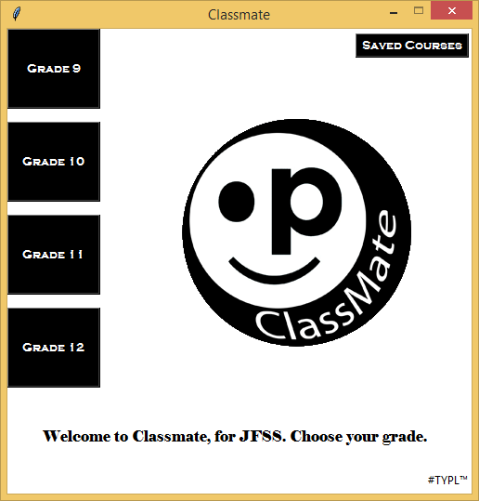The Start Screen

We built a clean, simple start screen. All you need to do is select the grade of which you are in, and you will be able to access all of the registered classes in that grade online through the confines of this clean, simple, easy to use, ClassMate application.

Course Selection Page

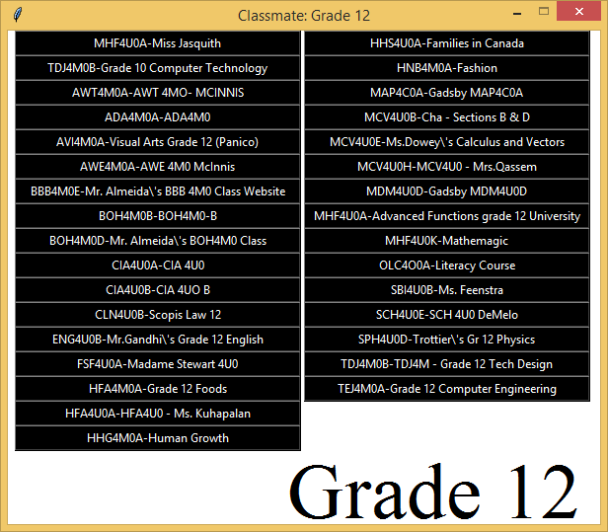

We made it easy to access all of the courses in each grade easy, and essentially, redefined speed and ease of use. When selecting a grade (Example above is Grade 12) you will simply see a list of buttons with all of the courses registered online and available to ping for further information such as due dates, tests and homework. To access this information, all you have to do is click on a button. It’s simple!

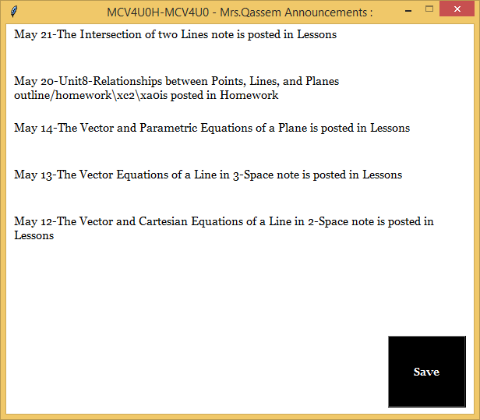Course View

You have arrived at your destination! You can now see all of the available information on due dates, tests and homework. All easy to read and use, now you can ensure you keep a note of it somewhere! Be prepared to ace your courses and know firsthand, all of the information you need to be successful in your classes. (Example above is Ms. Qassem’s Grade 12 Calculus and Vectors Class)

Important Mechanics

*Just a few things to keep in mind while using this program!*

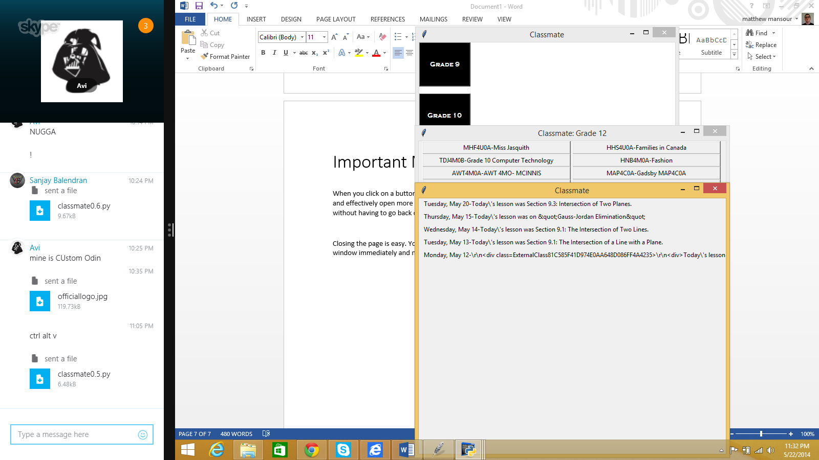

**Opening Windows**

When you click on a button, the page opens in a new window. We made it like this so that you can easily and effectively open more than one window to view more than one grade, and or class at the same time without having to go back or struggle with tough mechanics.

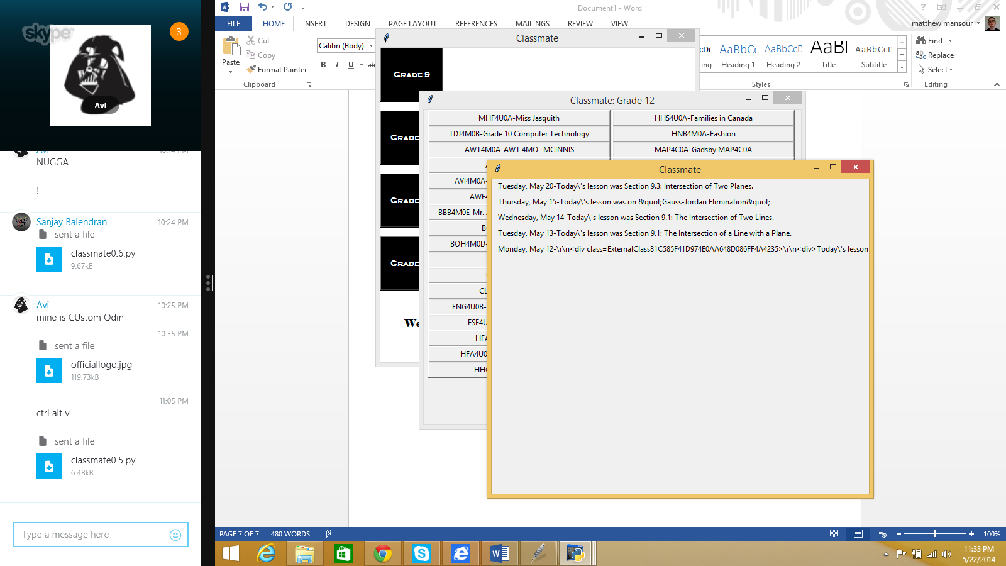

**Closing Windows**

Closing the page is easy. You never lose the start screen, so simply click on the red X! It closes the window immediately and now you can go on with the rest of the courses you have to check on!

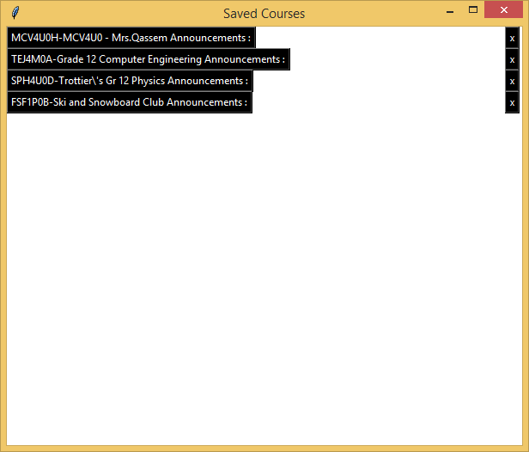

**Saving Courses**

When viewing a course’s page, if you click on the “Save” button, on the Start Screen, you can enter the “Saved Courses page.” This works perfectly for ensuring that you can efficiently and effectively access the courses you believe are the most important to you.



**Saved Courses Screen**

On the saved courses screen, you can easily access your favourite courses by clicking on the course name. To remove a course from this list, let’s say, if you made a mistake or have completed the course, simply click on the “X” button to remove.

Contact Us

If any problems arise or you’d like to give us feedback, you can reach us at the following:

Phone: **1(800) 4 NIP INC**

**1(800) 453 6351**

Email: **support@hashtagNIP.com**

Address: **1337 rue Hashtag**

**Paris, France,**

**75008**

**Thank You from #NIP Inc**